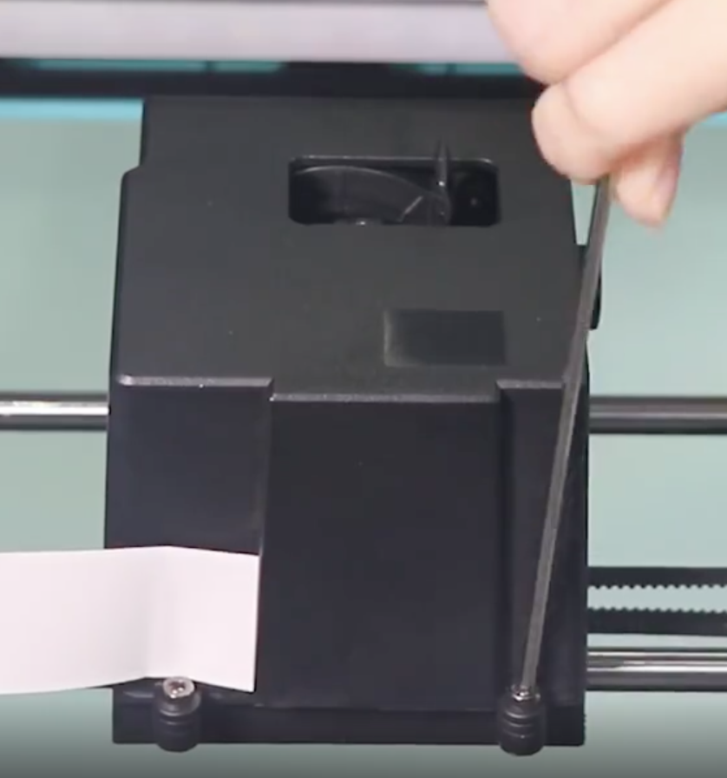

Remove two bolts on rear of print head cover.

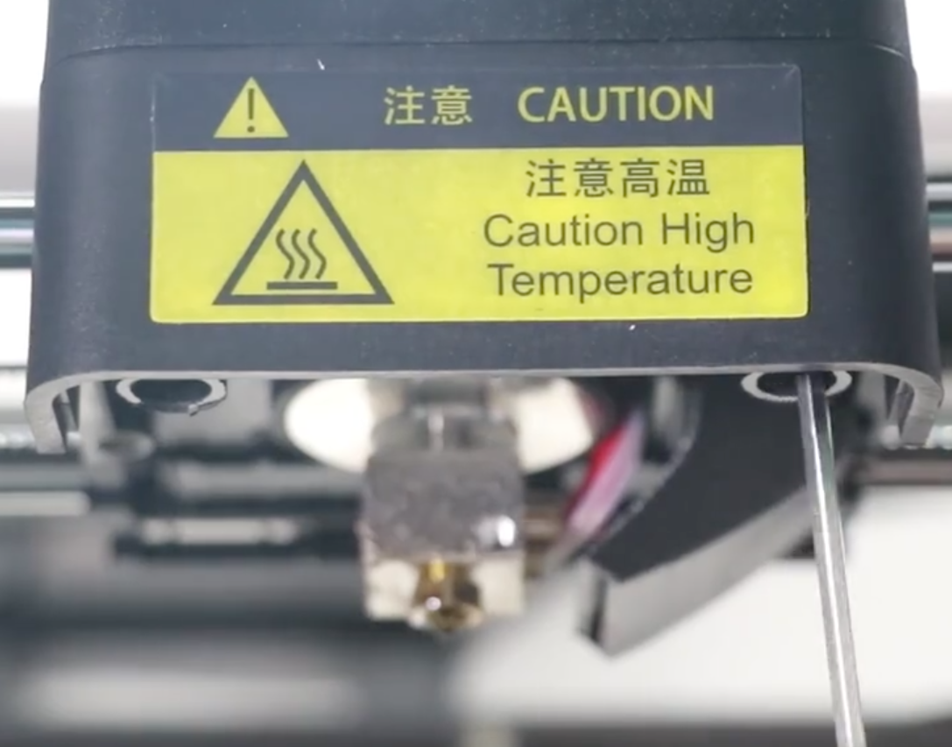

Remove two bolts from the front of the print head on the underside. Then remove the top cover.

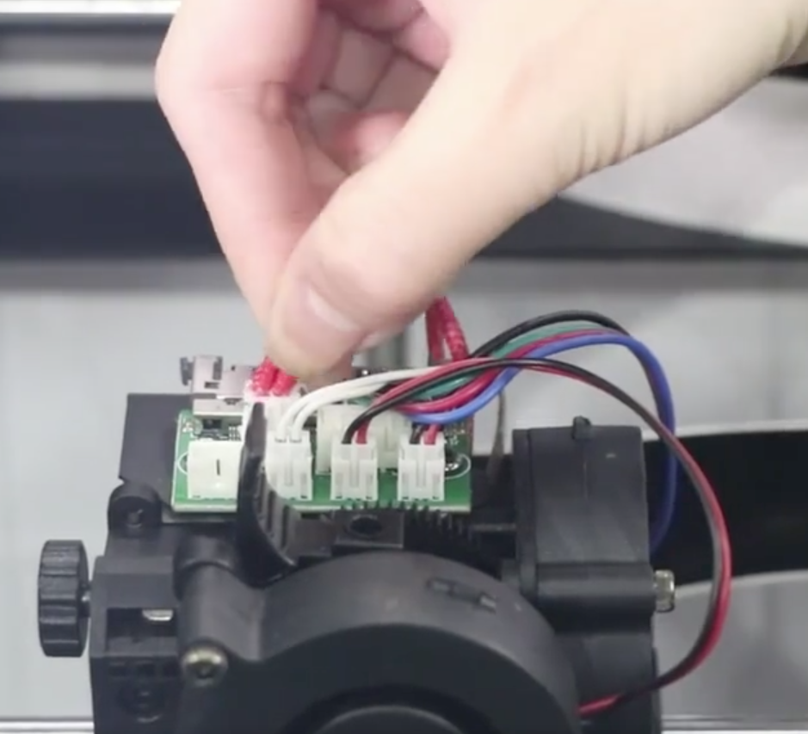

Remove the heating rod wiring connector

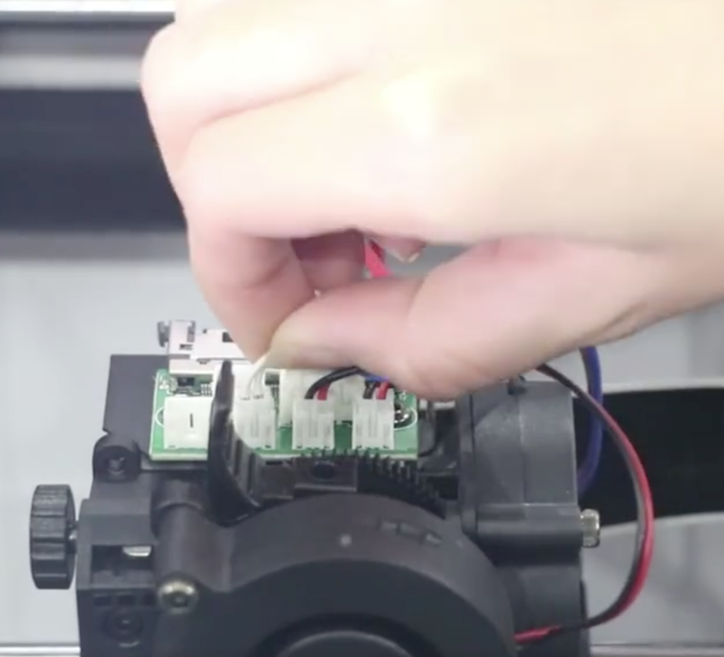

Then remove the thermistor wiring connector.

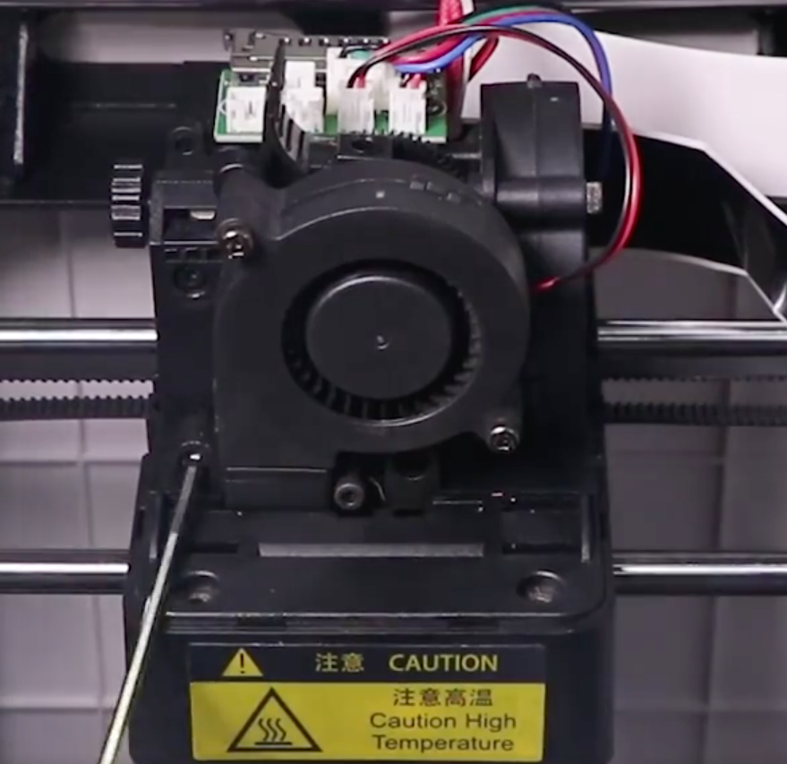

Remove the first of two (recessed) bolts securing the extruder assembly. NOTE that the first bolt is slightly longer than the second bolt for re-assembly.

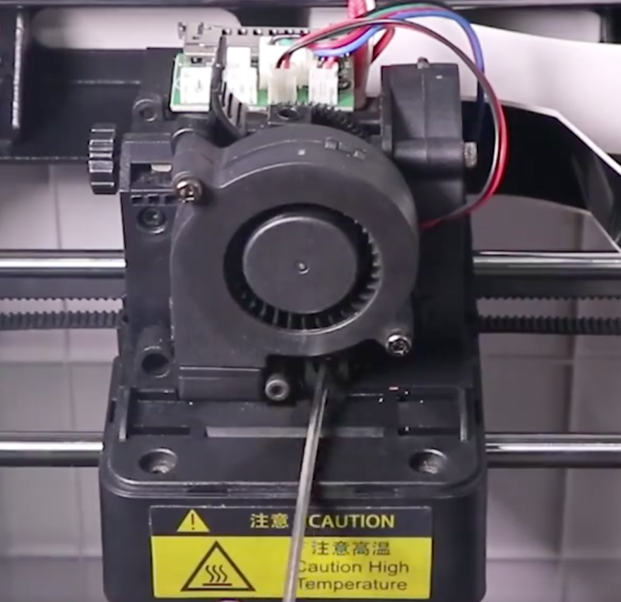

Then remove the second (recessed) bolt.

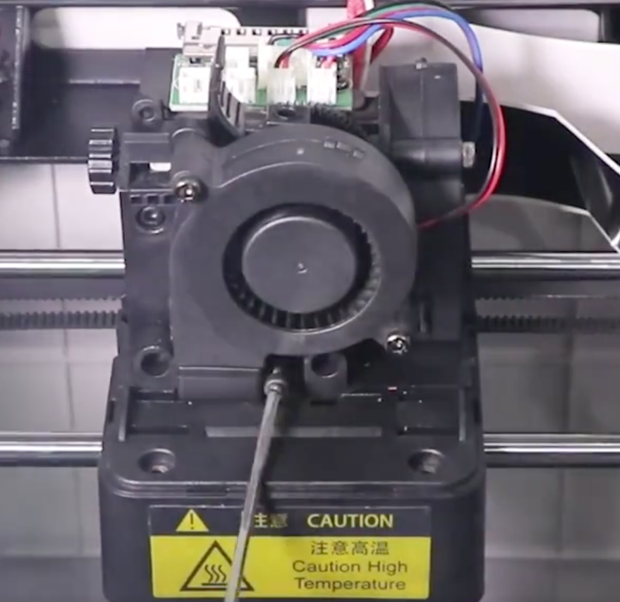

Carefully loosen (partially) the bolt that secures the print head. DO NOT unscrew this fully or the internal M3 hex nut on the inside will fall off.

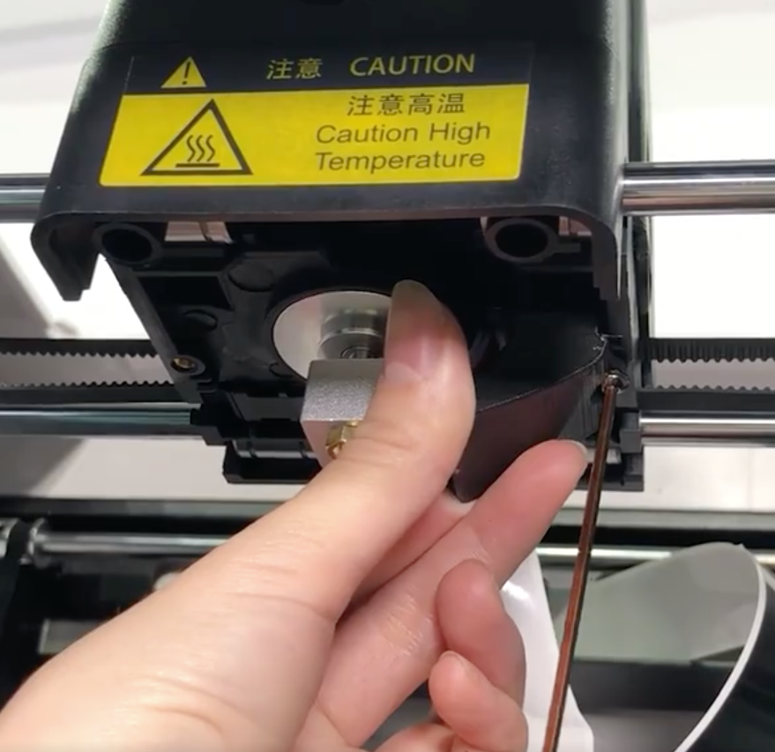

Remove the cooling duct by unscrewing the retaining bolt.

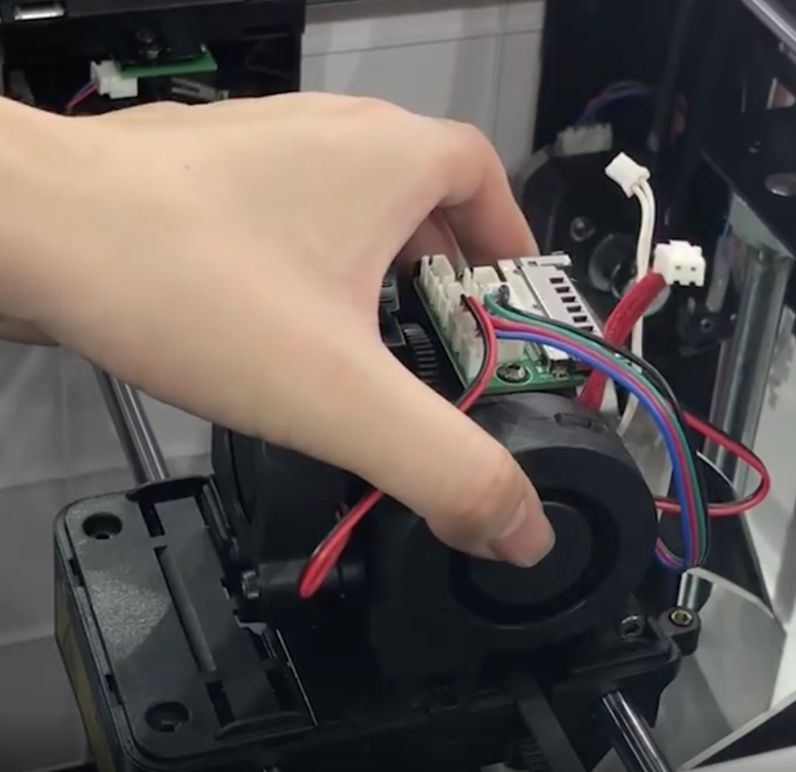

Carefully remove the extruder assembly

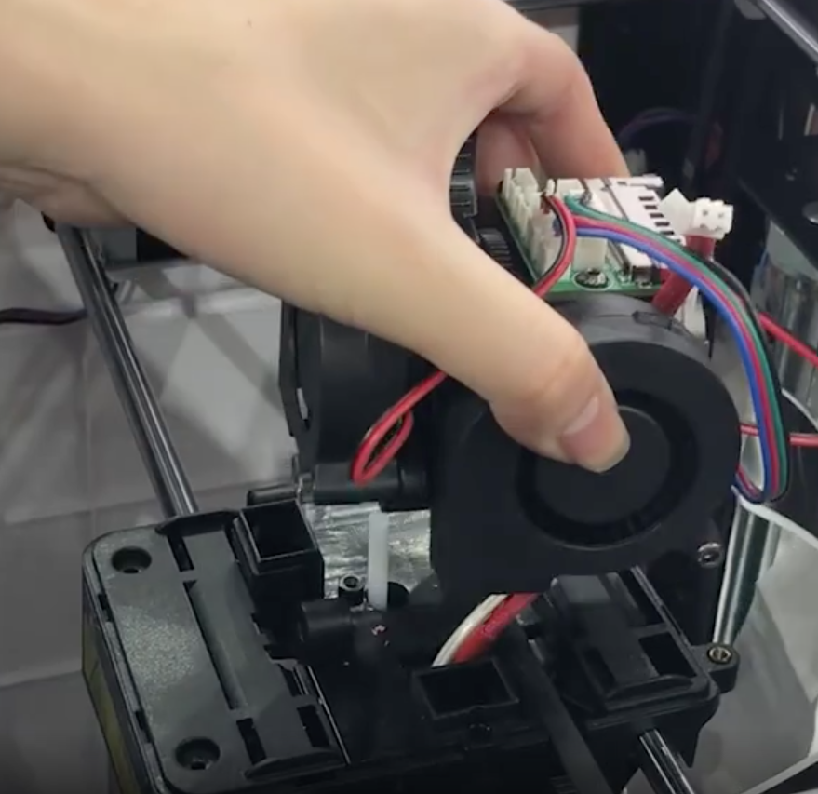

Carefully thread the disconnected heating and thermistor wires through the upper part of the extruder assembly.

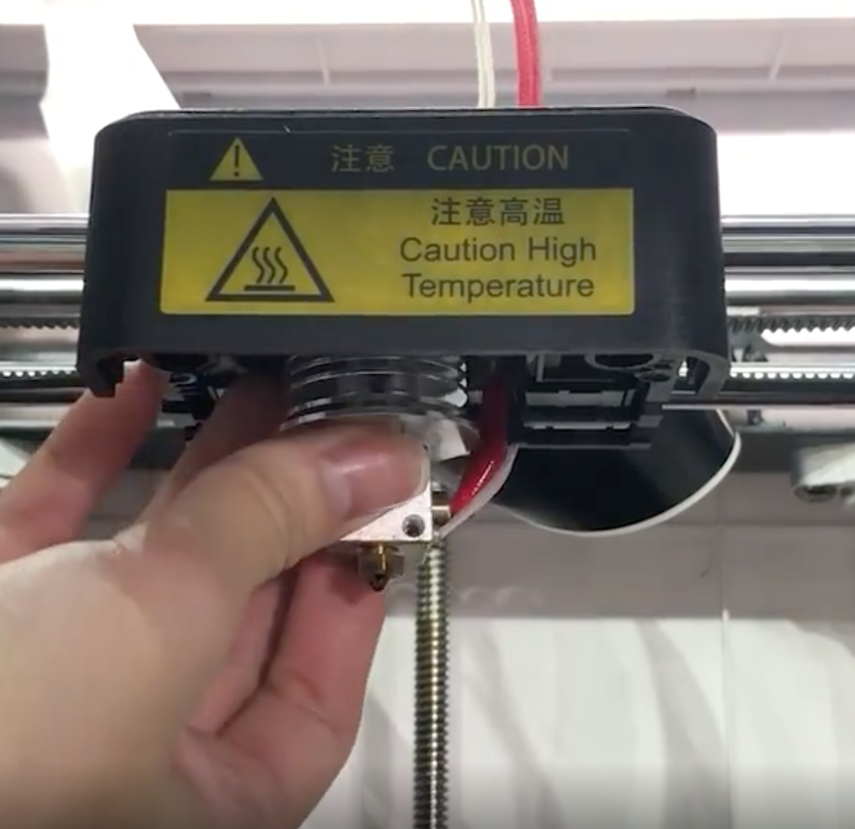

Remove the old print head.

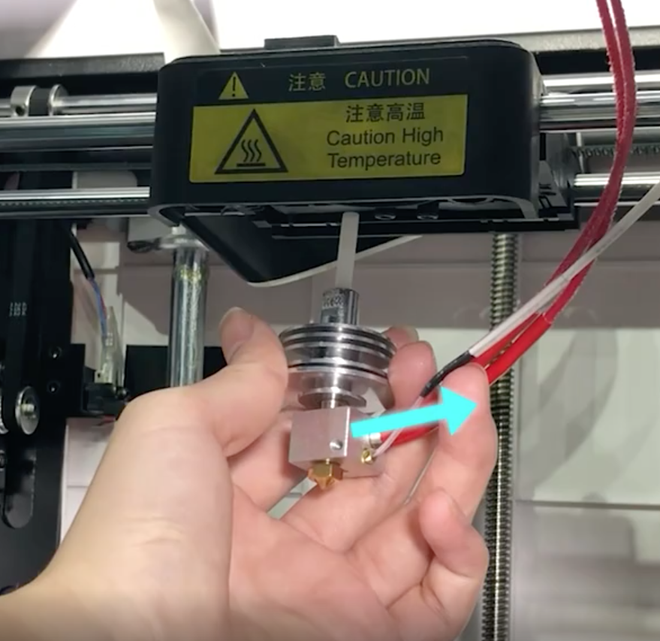

Install new print head, keeping wiring to the right hand side. Also note that the flat face on upper spigot is facing towards the front of the printer (this to accommodate the securing bolt which secures the print head)

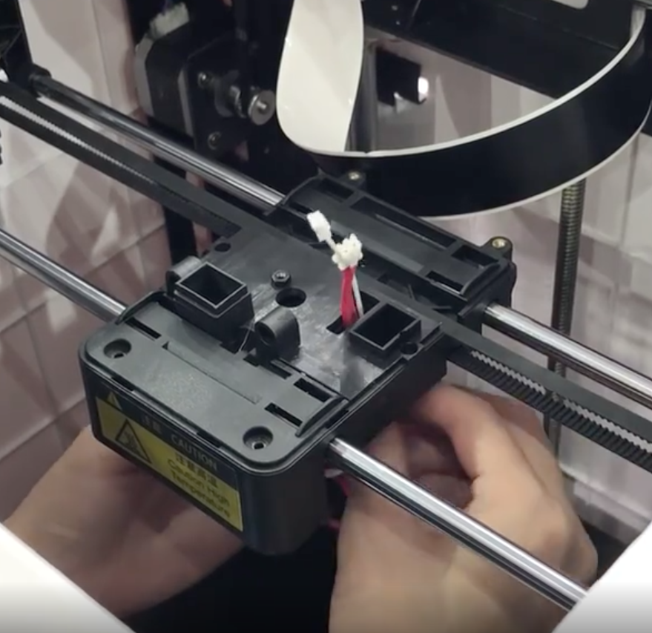

Thread the two print head wires up through the aperture adjacent to the fan duct.

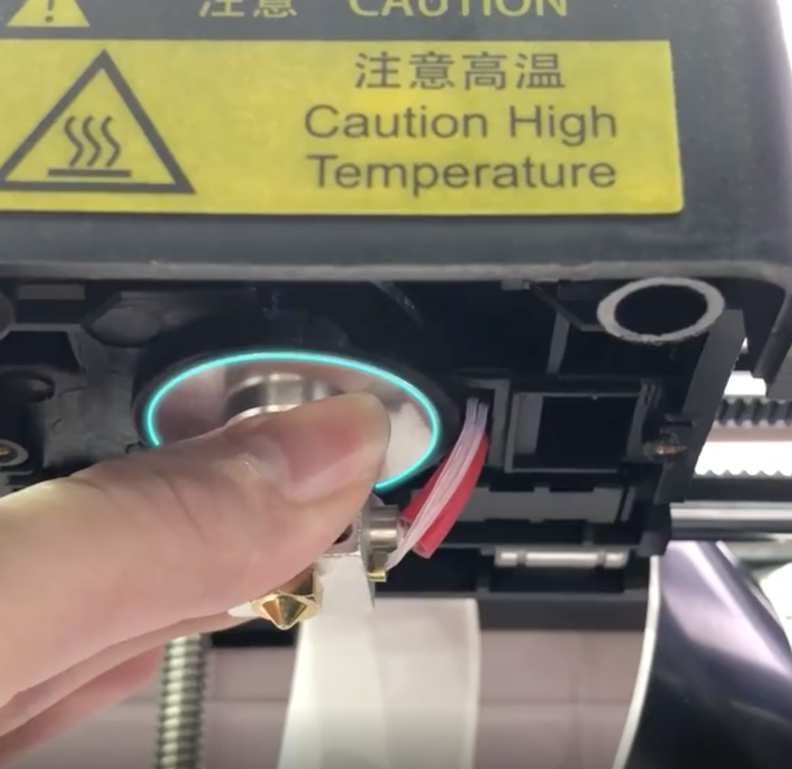

Ensure the print head is fully up in to its recess.

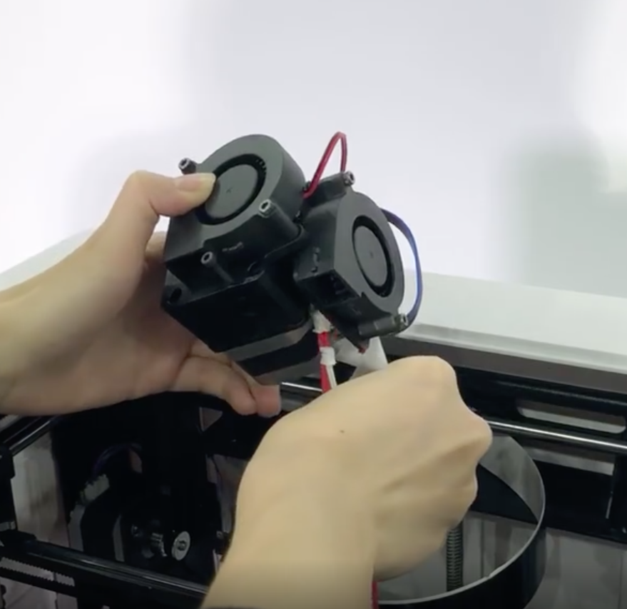

Thread the two print head wires back through the upper extruder assembly.

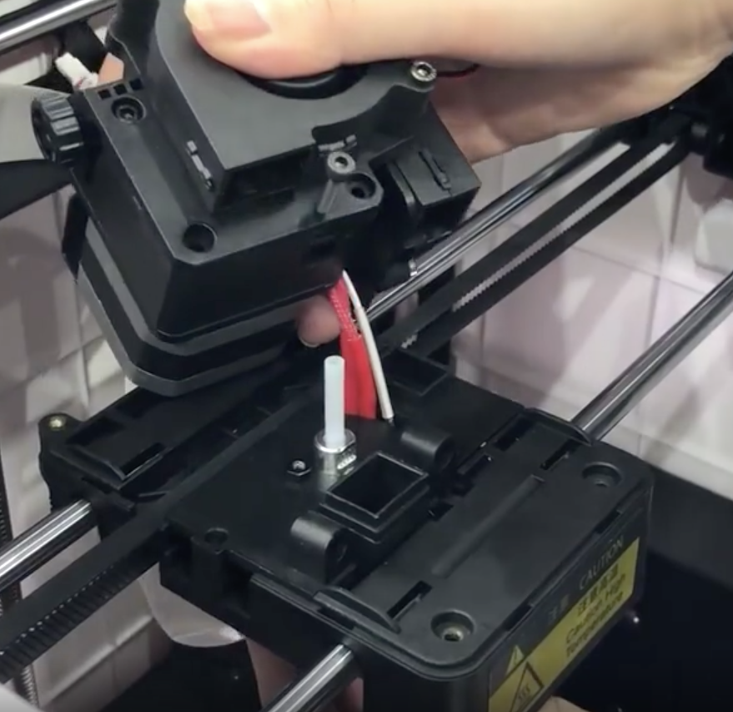

Reassemble ensuring all holes are properly aligned with their corresponding parts.

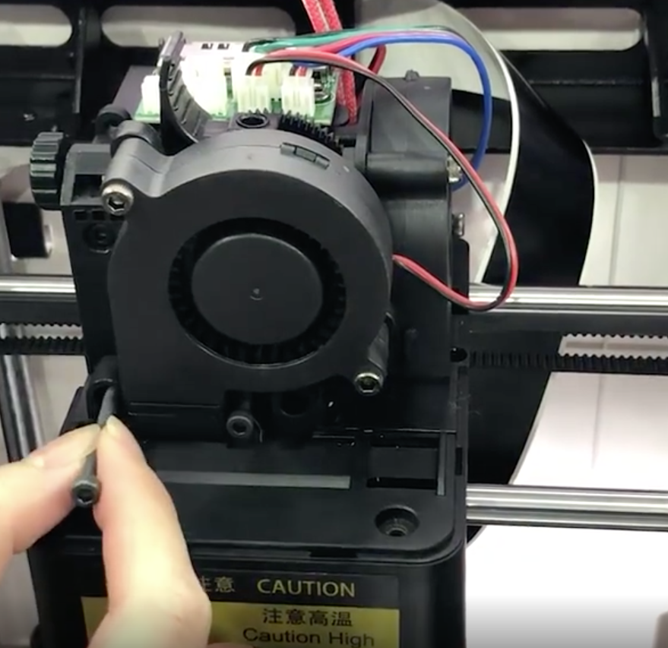

Secure the upper extruder assembly with the first (longer) bolt in the recessed hole.

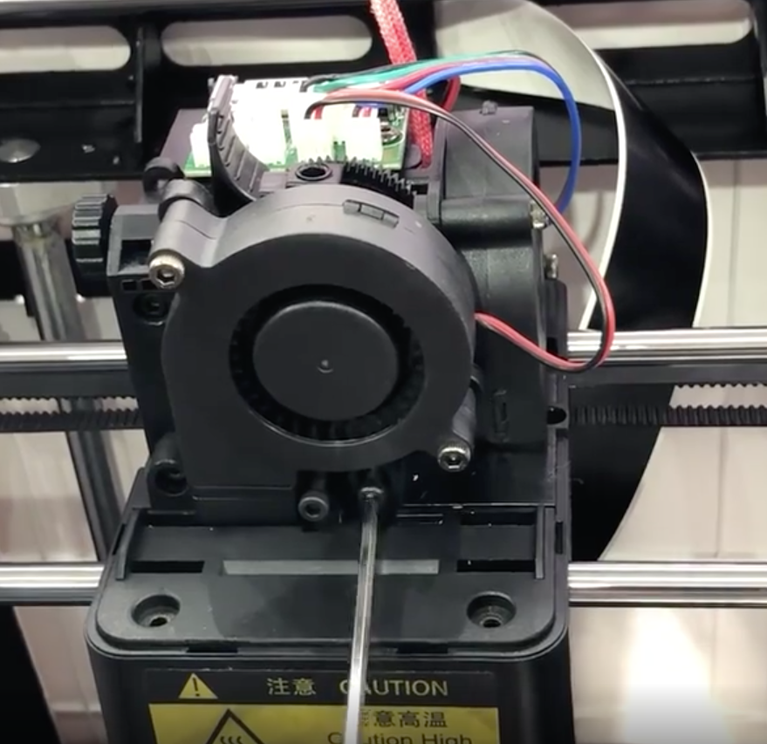

Then secure the second (shorter) bolt.

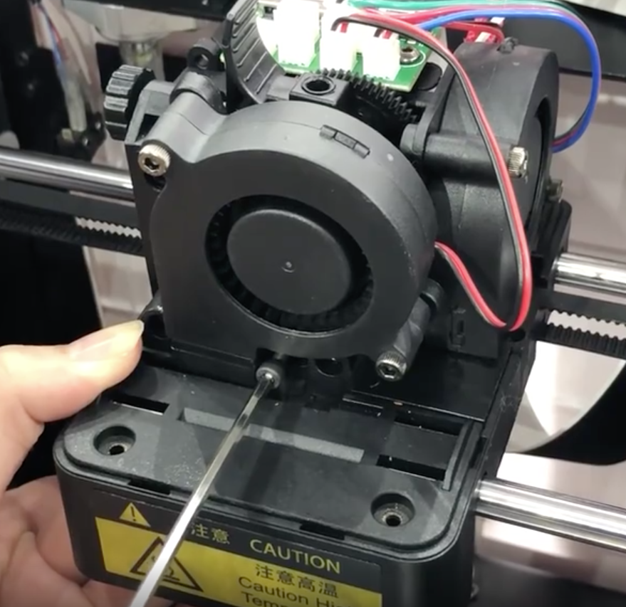

Ensuring the print head is still fully home (pushed up in its recess) tighten the print securing bolt.

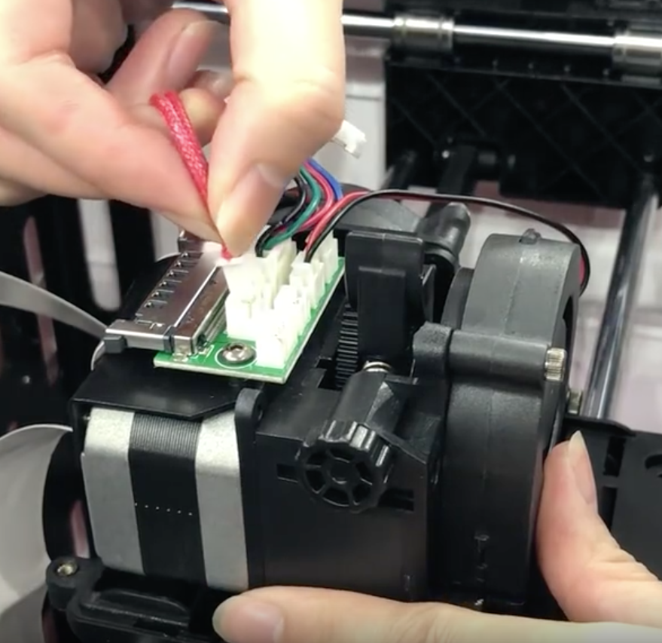

Reconnect the heating and thermistor wires to the PCB and then re-secure the print head cover with the 4 hex bolts.